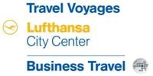

THE MAJESTIC BEAUTY OF VIETNAM & CAMBODIA 8 DAYS
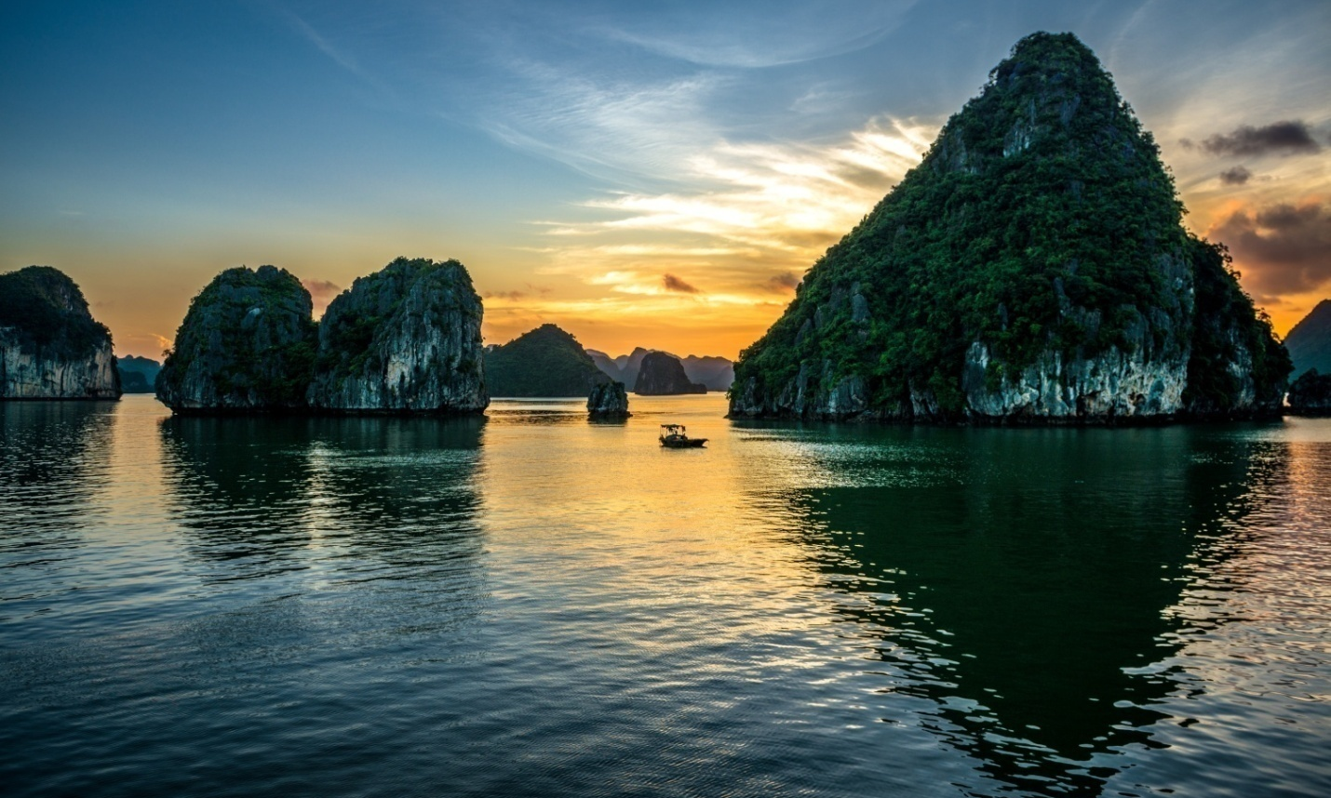
Code: VNCBD08
Routes: Hanoi – Halong – HCM City – Mekong – Siem Reap
Duration: 8 Days / 7 Nights
Features: An experience to 2 countries in one shot of 8 days, visiting the highlights of Vietnam, Cambodia, from easy sightseeing, traditional culture to interesting adventures, this is a trip of a lifetime.

Day 1: Hanoi arrival, Welcome to Vietnam
Chao Ban, Welcome to Hanoi – the capital city of Vietnam. Upon your arrival time, you will meet our tour guide at outside of arrival hall for airport transfer to your hotel in Hanoi.
Rest and overnight at your hotel in Hanoi

Inclusion: Transfer, guide and hotel
Day 2: Hanoi – Halong bay – Overnight on board
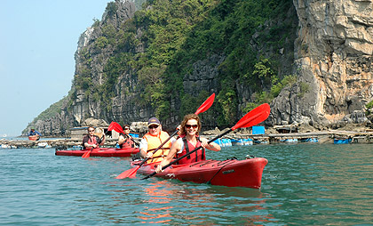
Departure for Ha Long Bay is around 8:00 AM in a shared van (about 4 hours) from your hotel. Arrive at the port around noon. Welcomed on board, you are taken to your cabin before the trip briefing. You enjoy a fresh and local seafood lunch while cruising to explore the magic Halong Bay. Stop for a swim and visit the mysterious cave. Relax at our secluded island-beach or explore by kayak. Later you return back to the boat just in time to watch the beautiful sunset from the top deck before enjoying the bay’s freshest seafood dinner.
Inclusion: Shuttle Bus, guide, entrance fees, kayak, boat/junk, all meals, permits.
Day 3: Halong Bay – Hanoi – Flight to HCM City
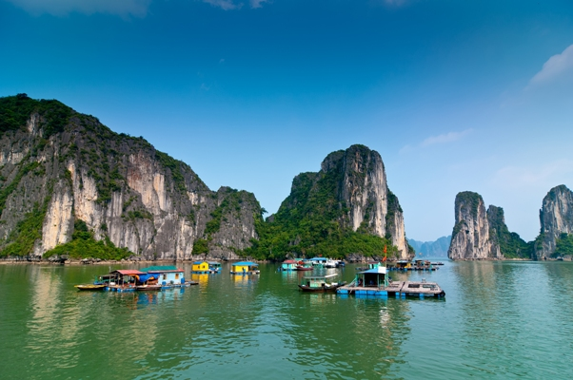
Early risers can enjoy the sunrise and the quiet breath-taking beauty of Bay’s landscape with towering limestone. You have breakfast at around 8:00 AM before our short rowboat by the locals of the bay.
Lunch on the boat as we slowly cruise back to boat pier. Hit the road to get back Hanoi around 04:30 PM.
Dinner at your own account before our driver take you to airport for flight to HCM City. Upon your arrival time, you will meet our tour guide at outside of arrival hall for airport transfer to your hotel in HCM City.
Rest and overnight at your hotel in HCM City

Notes: Arrival Hanoi time from Halong Bay is around 05:00PM. If you book flight from Hanoi to HCM City by your own, please make sure that the departure time is after 07:30 PM. If it is earlier than that, please inform me for upgrade to Private car for Halong Bay trip then we will transfer straight to airport from Halong Bay. Price for upgrade will depend on group size.

Inclusion: Shuttle Bus, guide, entrance fees, boat / junk, row boat, breakfast, lunch and hotel
Day 4: HCM City tour – Cu Chi Tunnel tour
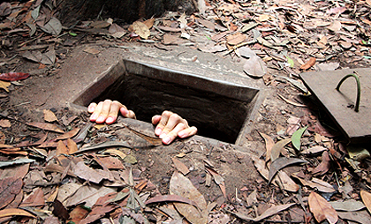
Get started at 8:30 AM from your hotel venturing out to the Cu Chi countryside. See what life was like for the guerrilla warriors who lived and fought underground during the war. Crawl through 50 m of the 200 km tunnel system below. This morning will also see a visit to a rice paper workshop.
In the afternoon see the real HCM City through the eyes of a local. Visit the bustling Cho Lon market and a hidden Chinese pagoda, the Notre Dame Cathedral, the historic Central Post Office, and City Hall. We drop you off at your hotel around 5:30 PM.
Inclusion: Transfer, guide, entrance fee, breakfast and hotel.

Day 5: HCM City – Mekong delta
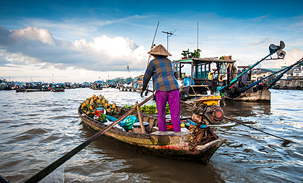
Getting started at 8:30 AM from your hotel, then a drive about 70 km out of HCM City to see Mekong Delta life around My Tho. Driqft down the busy branches of the Mekong and into its peaceful canals. Visit an island orchard, and experience daily life of the farmers here. Try exotic seasonal fruits unique to the region and explore the quiet island on foot.
Take a local cruise, stopping to learn how to make coconut-candy. Visit a bee farm to try some local honey with rice wine or tea then head back to HCM City. Tour ends around 4:30 PM.

Inclusions: Transfer, guide, entrance fees, boat trip, breakfast and hotel

Day 6: HCM City – Flight to Siem Reap

Breakfast at your hotel then meet our driver at the lobby for transferring to airport for flight to Siem Reap.
Upon your arrival time, you will meet our tour guide at outside of arrival hall for airport transfer to your hotel in HCM City.
In the afternoon, we will transfer to Tonle Sap Lake for taking boat trip to visit at Kompong Pluk, where we will have the opportunity to learn about life on the lake. On the way, we will pass floating houses and impressive flooded forests, portraying life on the water. Return back in town, we will go to visit Artisans d’Angkor. In there, we can take a tour through the workshops and watch students as they learn how to create silk fabrics and garments, stone and wood carving, lacquer ware, polychrome products, silver plating and silk paintings.

Inclusion: Transfer drop off, breakfast, boat trip, guide and hotel
Day 7: Siem Reap – Angkor tour
After meeting our tour guide, then we drive to Angkor Thom that was the masterpiece of King Jayavarman VII. We begin to visit Bayon Temple. At the exact center of Angkor Thom, this is an eccentric expression of the creative genius and inflated ego of Cambodia’s most celebrated king.
We continue to visit Terrace of the Leper King. This intricately carved platform was the royal crematorium and the statue that was originally thought to be the leper king is now believed to be Yama, the god of death. We continue along the Terrace of Elephants. At the southern end lies the Baphuon, once of the most beautiful temples at Angkor, dating from the reign of Uditayavarman 1 in the 11th century. You'll break for lunch at a local restaurant before the 15-minute drive to Ta Prohm, the monastery-temple of Tomb Raider fame.
We journey out to the Mother of all temples, Angkor Wat. Believed to be the world's largest religious building, this temple is the perfect fusion of symbolism and symmetry and a source of pride and strength to all Khmers. We venture into Angkor Wat to enjoy its magnificence in peace and quiet. We begin by unraveling the mysteries of the bas-reliefs that tell of tales from Hindu mythology and of the glories of the Khmer empire.
Overnight in Siem Reap.
Inclusion: Transfer drop off, breakfast, entrance fees, guide and hotel

Day 8: Siem Reap – Departure
Transfer to SIEM REAP airport for departure to next destination. It’s time to say goodbye, we thank you for traveling with us and warmly welcome you to come again.
Inclusion: Transfer drop off and breakfast.

3* Hotel proposal:
- Hanoi: Silk Queen Hotel
- Halong: Oriental Sail Cruise
- Ho Chi Minh City: Lavender Hotel
- Siem Riep: Frangipani Villa Siem Reap Hotel

4* Hotel proposal:
- Hanoi: Silk Queen Grand Hotel
- Halong: Paloma Cruise
- Ho Chi Minh City: Harmony Hotel
- Siem Riep: Somadevi Angkor Hotel

5* Hotel proposal:
- Hanoi: Hanoi Hilton Hotel
- Halong: Alisa Cruise
- Ho Chi Minh City: Majestic Saigon Hotel
- Siem Riep: Angkor Miracle Resort

Costs are $US NET, 3% surcharge if pay by credit card. Other surcharges might be applied such as Tet holidays.

Exclusion: Compulsory gala dinner and additional surcharge on Christmas and new year period, Visa, Insurance, drinks, personal expenses, others not mentioned in details, tips are welcome!

LEGAL ASPECTS
Booking Terms & Conditions: Tour itinerary and tour prices are subject to change without prior notice. Please click here for more information.

ORGANISATION
Transportation schedule: Please be aware that flight times, trains, hotels and other services are subject to availability. When flights/trains are cancelled or delayed, we will endeavour to secure alternative arrangements of similar value. Hotel, flight and train details will be updated once the booking is confirmed (your confirmation e-mail).
Tour guide: English speaking guides (on sites)
Closed sites: Some sites might be closed during the time you visit Vietnam (e.g. the HCM mausoleum in Hanoi is closed on Mondays and Fridays). Please consult with your travel agent if you want to have further information concerning this issue.
ACCOMMODATION
Hotel: We use 4 star standard hotels, twin shared room (s). Upgrade is available on request. Check – in: 14:00; out: 12:00 noon. Early check in if it is subject to availability.

TRANSPORT
Car/Van Quality: Using new AC car or van depending on your group size.
FOOD
Meals: Local foods and seafood’s. If you have any allergies, special requests or if you are on a special diet please let us know. We will arrange it for you in advance.
SUSTAINABILITY
Please Travel Responsibly: The small things you do will make a big difference!
PREPARATION OF THE CUSTOMER
What to Bring: Passport, change of clothes, sunglasses and hat, toiletries, sunblock, insect repellent, flashlights, good sport shoes, personal first aid kit and medicines, small local notes for buying drinks. If you feel the need then sleeping bags and a cable lock for your bags is recommended.

ADDITIONAL INFORMATION
This itinerary and supplementary information has been complied in good faith and was accurate at the time of writing.

