Explore Jordan
5 Days – 4 Nights
Amman – Jerash – Madaba – Mt. Nebo – Kerak – Petra – Wadi Rum – Dead Sea

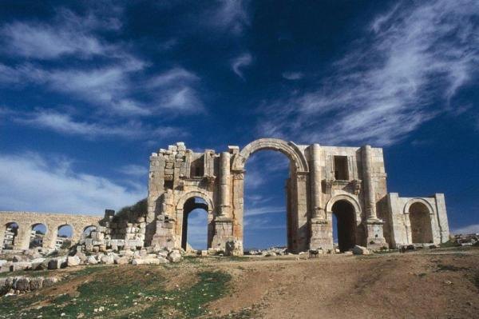
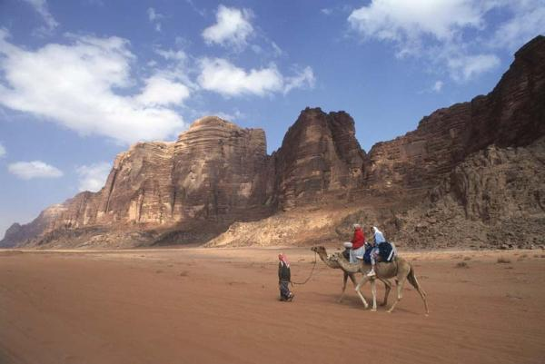
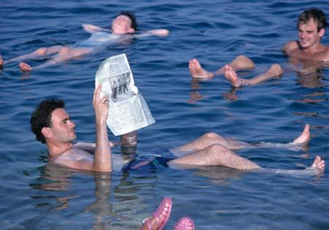

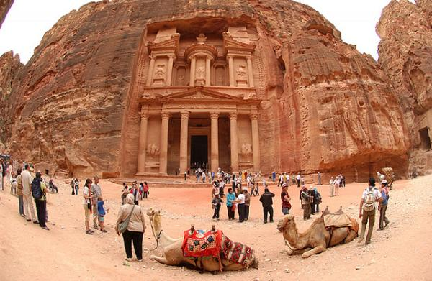

Day 1 Arrive Amman / Amman
Arrival at Queen Alia International Airport, Transfer to your hotel in Amman. Overnight at the selected hotel as per meal plan.

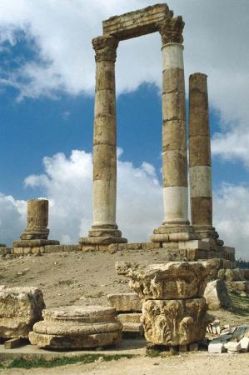
Day 2 Amman / Amman City Tour / Jerash / Amman
Breakfast at the hotel. After breakfast, embark on a city tour of Amman, the capital of the Kingdom of Jordan. Often referred to as the "White City" because of the white stone used to build the houses, Amman is among the oldest continually inhabited cities on Earth. The tour will take you to the museums, the Citadel, the Roman Amphitheater, the souks, and the city's modern district. Then travel north of Amman to the best preserved example of

Roman civilization in Jordan, the city of Jerash. Jerash, part of the Decapolis (the ten large Roman cities of the East) has been called the Pompeii of the East for its unique state of preservation. The city features theaters, churches, temples of Zeus and Artemis, a Nymphaeum and colonnaded streets. Later, return to Amman. Overnight at the selected hotel as per meal plan.

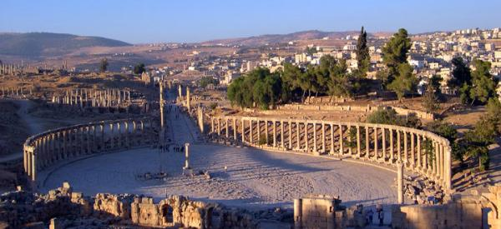

Day 3 Amman / Madaba / Nebo / Kerak / Petra
Breakfast at the hotel. This morning en route to Petra, visit the mosaic city of Madaba, where an ancient map of the Holy Land is set into the floor of Saint George's Church. Continue to visit Mount Nebo, the reputed burial site of Moses, overlooking the Jordan Valley and the Dead Sea. Then drive through the beautiful scenery of Wadi Mujib to Kerak for a visit of the Crusader Castle before arriving in Petra. Finally, drive to the Petra. Overnight at the selected hotel as per meal plan.
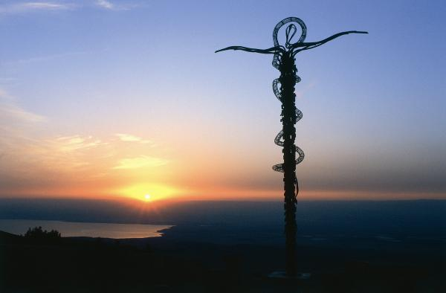
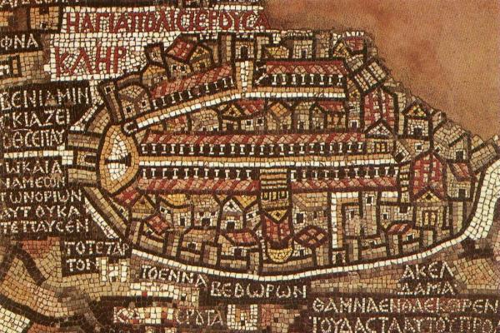

Day 4 Petra / Petra visit / Wadi Rum
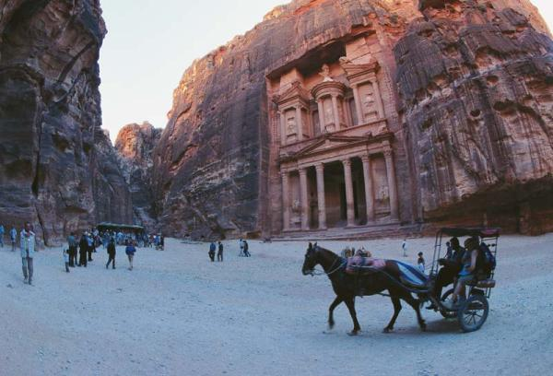
Breakfast at the hotel. Today, enjoy a tour of Petra, both a Jordanian national treasure and a UNESCO World Heritage Site. The ancient capital of the Nabataeans, Petra once sheltered Arab traders who came through the region with precious cargoes of spices, silks, ivory, and rare pelts. See the towering treasury, a building rising 140 feet that is cut into the sheer rock face. Along the way, you will also see the impressive architecture of countless temples, water channels, arched gates, and royal tombs, the remnants of a once great culture. Continue to visit the Wadi Rum Desert, and its magnificent moon-like landscape. Take a short ride in a 4x4 vehicle. Overnight at the camp as per meal plan.

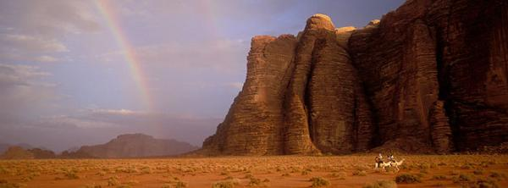

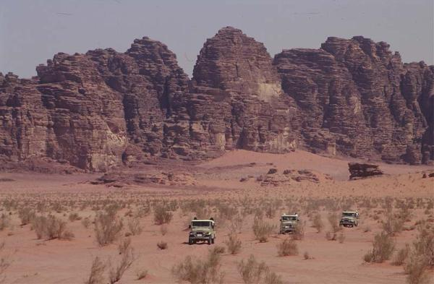
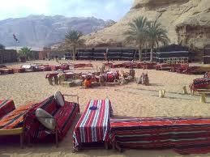

Day 5 Wadi Rum / Dead Sea / Amman / Departure
Breakfast at the camp. Then drive to the lowest point on Earth the
Dead Sea for relaxation and rejuvenation. After visit Dead Sea beach drive to Amman to take rest before departure.

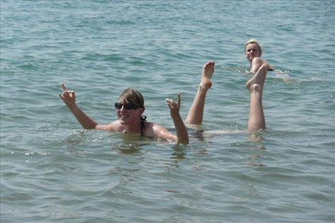
And finally transfer to the airport. Assistance with formalities by a member of our staff and departure.
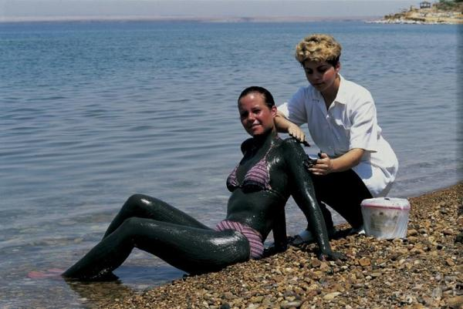
Inclusions
- Accommodation:
  - Amman: 2 Nights including Breakfast.
  - Petra: 1 Night including Breakfast.
  - Wadi Rum: 1 Night Bedouin Camp (Tent) including Dinner & Breakfast
  - Amman: Day use room on day of departure (if Flight after 10 pm).
- Transportation in a private air-conditioned deluxe car/mini van
- English speaking Tour escort
- Entrance fees as per program
- English Speaking Local Guide in Petra (4 Hours) and Jerash (2 Hours)
- Horse Ridding in Petra (800 Meters)
- Lunch in Dead Sea Spa Hotel (open buffet)
- Two hour Jeep tour in Wadi Rum
- Water & soft drinks throughout the trip in vehicle
Exclusions
- Personal Expenses
- Drinks in Restaurants mentioned in the program
- Tips to the Driver & Guide

General Information about Jordan

Orientation
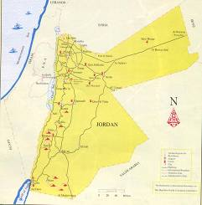
The Hashemite Kingdom of Jordan lies in the heart of the Middle East. Jordan is bordered by the West Bank and Israel from the west, Syria from the north, Iraq from the northwest, Saudi Arabia from the southeast and Egypt from the southwest.

Time zone:
Jordan is 2 hours ahead of GMT (Greenwich Mean Time)

LOS ANGELES NEW YORK G.M.T. JORDAN TOKYO SYDNEY
05:00 07:00 12:00 14:00 19:00 20.00

Climate:

Hot and dry summers with cool evening. The Jordan Valley below sea level is warm during winter and extremely hot in summer. Rain falls between November and March, while colder weather conditions occur in December / January.

Required clothing: Lightweight cottons and linens are advised between May and September. Warmer clothes are necessary for winter and cool summer evenings. Rainwear is needed from November to April.

Local daytime temperatures range as follows for the year (°C):
 |  | Jan | Feb | Mar | Apr | May | Jun | Jul | Aug | Sep | Oct | Nov | Dec
Amman | High | 12 | 13 | 16 | 23 | 28 | 31 | 32 | 32 | 31 | 27 | 21 | 15
 | Low | 4 | 4 | 6 | 9 | 14 | 16 | 18 | 18 | 17 | 14 | 10 | 6

Visas:
All nationalities require tourist visas for Jordan. A visa can also be obtained at Amman’s Queen Alia International Airport, or any other main border; payment must be in local currency JD 40. Group visa can be arranged free of charge for groups of 5 adults and over arriving together and staying in Jordan a minimum of 2 nights, provided you send us a visa list with full passport details prior group arrival.

Currency:
The local currency is the Jordanian Dinar, or “JD”, which is divided into 1000 fils. The current exchange rate is US $100.00 is equal to JD 71.000.

Credit Cards:
American Express, Visa, and MasterCard are widely accepted, whilst Access and Diners Club have more limited use. Check with your credit card company for details of merchant acceptability.

Tipping:
Tipping is never required but always appreciated. In hotels and restaurants, 10% may be added to the bill, but a small tip for the waiters is appropriate. For hotel bellmen and porters 2 JOD, or US$ 3 is customary. Visitors would normally consider tipping their guide, driver on tours, hotel staff, and waiters in restaurants.

Photography:
If you are taking photographs of local people, always ask their permission beforehand. Your guide can assist you in this. Do not take photographs of military installations or airports. Film is readily available in all tourist areas. It is advisable to carry your camera in a dust-proof bag.

Electricity:
The electrical system is based on 220 AC volts, 50 cycles, and requires rounded two prong wall plugs. Visitors from the United States of America will need a transformer; most hotels can provide one.

Shopping:
Jordan is a shoppers’ paradise offering hand-blown glassware, inlaid boxes, silver, gold, Jewelry, brass, copper, carpets, antiques, leather wear, spices, perfumes, alabaster, embroidered covers, wall hangings and furniture. It is prohibited to export any ancient artifacts. Be careful when investing in “genuine antiques” which in many cases are excellent forgeries.

Dress Code:
Jordan is primarily a Muslim country, although the freedom of all religions is protected. Revealing clothing is never appropriate and conservative clothing is advisable for both men and women in downtown Amman and in rural areas. Topless sunbathing is prohibited and one-piece swimsuits are preferred, although two-piece swimsuits are acceptable in hotel pools or beaches. Evenings can be cool in summer, so a sweater or a shawl is advisable.

