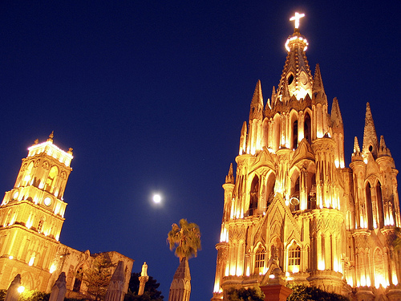
Colonial Treasures & Punta Mita
Deluxe services

DAY 01
EUROPE – MEXICO CITY
At your arrival at the airport in Mexico City, you will be met and assisted for our English speaking guide and transfer in a private vehicle to the Hotel Down Town (Boutique): Built in the 17th century, Downtown Hotel is an historic, former palace providing 17 beautiful suites. Further charming features include a bar and swimming pool on the rooftop with city views and all within just two blocks of Mexico City’s central square, El Zocalo.
Our Suggestion about Room: Colonial Queen; Facing a 17th century courtyard, the Colonial Queen Rooms feature high ceilings and original antique construction materials. The wooden furniture, queen size beds and spacious bathrooms, create a unique and cozy environment for relaxing. Dinner included arriving at the hotel before 22h00

DAY 02
MEXICO – CITY TOUR – TEOTIHUACAN
Breakfast at the hotel
This morning you will visit Mexico City’s historic square and Anthropology Museum (Closed on Mondays).
The Anthropology Museum contains significant archaeological and anthropological artifacts from the pre-Columbian heritage of Mexico, such as the Piedra del Sol.
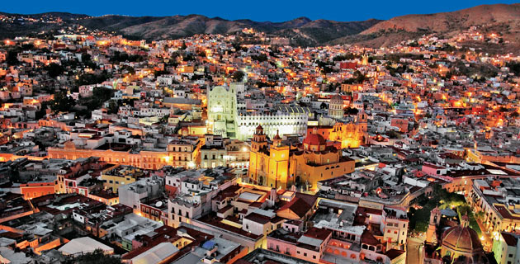
Continue to Visit National Palace, Metropolitan Cathedral and Zocalo Square: The roots of Mexico's capital lie in the so-called Historic Center, an area which occupies the original core of the city which the Aztecs set out like a celestial map, aligned according to the four cardinal points.
You will continue to Teotihuacan, and visit the archeological site. Teotihuacan is an enormous archaeological site in Mexico, containing some of the largest pyramidal structures built in the pre-Columbian Americas. After the visit we will return to Mexico City
Overnight at the Hotel

DAY 03
MEXICO – QUERETARO – SAN MIGUEL DE ALLENDE
Breakfast at the Hotel
Departure to Queretaro, Santiago de Queretaro was founded in 1531, among bloody battles between native Indian and Spanish conquerors. The historic downtown offers the visitor over 460 years of history and tradition through its aqueduct, temples, mansions and palaces that make of this city one of the most beautiful colonial spots.
Continue the trip to San Miguel de Allende. Arrival and Lodging in the Hotel Casa Sierra Nevada: A cluster of historic buildings at the centre of the city; this charming Orient-Express hotel offers the ultimate Mexican experience. Cool, leafy gardens, stone arches and traditional wooden doors surround pretty courtyards lit by lanterns as night falls.
Our Suggestion about Room: Superior Room; each room is individually decorated in the local style, which is a mix of Spanish Colonial and Mexican. Most rooms have quarry-stone fireplaces; all have exquisite furnishings, talavera-tiled bathrooms.
In the afternoon, visit to San Miguel de Allende, is the new Cultural Heritage for Humanity was declared on July 7, 2008 by the UNESCO and will conserve its unique life style with an artistic & cultural ambience.
Overnight at the Hotel

DAY 04
SAN MIGUEL DE ALLENDE – DOLORES HIDALGO – GUANAJUATO
Breakfast at the Hotel
After the breakfast we will departure to Guanajuato, visiting in the route the charming village of Dolores Hidalgo, where in 1810 the father Don Miguel Hidalgo began the Mexico’s Independence war.
At your arrival in Guanajuato you will be Lodge at the Hotel Quinta Las Acacias; a Mexico Boutique Hotel member, was built in a XIX century French style mansion, and restored very carefully in 1998 to create a luxury hotel. They succeeded in joining/mixing the classic European style furniture and antiques with the Mexican handicraft beauty; such merge, creates an elegant and welcoming atmosphere in all the rooms and areas which invite the guests to relax and enjoy an unforgettable stay.
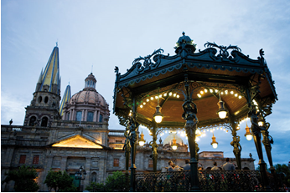
Suggestion about Room: Standard Classic Room; decorated in European classic style, with balconies facing the park, located in first floor, each one has its own style preserving the original flavor of the house some has antiques, all with wooden floors and oriental carpets , you will be transport in time as soon as you get in.

City tour of Guanajuato: This city is considered by many people as the most important Colonial city in America, we will visit: The Union Garden, the Juarez Theater, the Peace Plaza the University of Guanajuato and the Famous Guanajuato Mommy museum.
Overnight at the Hotel

DAY 05
GUANAJUATO – GUADALAJARA – TLAQUEPAQUE – GUADALAJARA
Breakfast at the hotel
After breakfast, departure to Guadalajara and visit to the City: The Mexican state of Jalisco with its capital in the city of Guadalajara being the birthplace of Mexican Tequila, Mariachis and Charros is rightfully considered as the heart of Mexico.
Guadalajara is the city-symbol of Mexico that offers the best of Mexican music, national cuisine and traditions. It`s known as the most musical city of Mexico and Mariachi bands are an integral part of its life. After you will have a chance to visit a small town of Tlaquepaque – the center of Mexican arts where you will discover and enjoy the fascinating work of modern artists, traditional Indian art, galleries and restaurants.
Continue to our hotel, the Hotel Villa Ganz;
Housed in a historic 1930s mansion, Villa Ganz has been acclaimed as the First Luxury Boutique Hotel in Guadalajara. It has 10 beautifully restored rooms decorated in exquisite good taste. Guests will find picturesque corners and magical spaces in this two-storey villa, which brilliantly evokes the noble mansions of yesteryear.
In 2009 we decided to identify our suites with names instead of numbers, the better to pay homage to the renowned writer Juan Rulfo, a native of Jalisco. Rulfo is considered to be one Mexican literature’s most esteemed authors and his work has been translated into nearly every language.

DAY 06
GUADALAJARA – TEQUILA – PUERTO VALLARTA
Breakfast at the hotel
After breakfast, we will departure to Puerto Vallarta. In the route we will visit to Tequila Village.
In Tequila, You will hear the story of this legendary beverage and find out about field cultivation of the blue agave. You will walk the cozy little streets of the Tequila town, the name of which decided the fate of these lands.
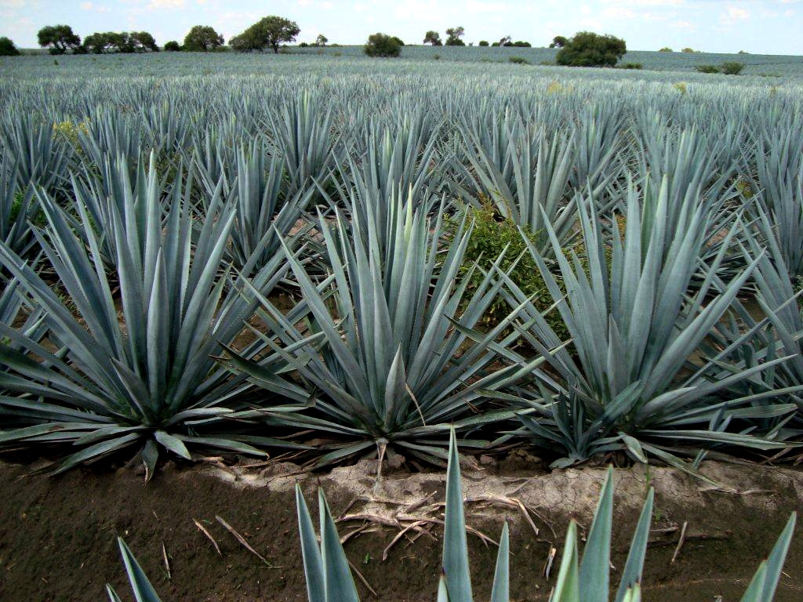
After the wonderful visit to tequila, we will continue our trip to PUNTA MITA where we will spend one night at the St. Regis, were you can have the opportunity to have an inner-body balance with a yoga lesson
Overnight

DAY 07
PUNTA MITA
Day at leisure at Punta Mita. The areas surrounding Punta Mita have been considered a place for spiritual renewal for centuries, now besides this, is one of the most exclusive destinations in Latin-America.
Overnight

DAY 08
PUNTA MITA - MORELIA
Breakfast at the Hotel
Departure to Morelia, to visit the city
Morelia was founded by Spaniard Don Antonio de Mendoza in 1541 under the name of Valladolid; it was renamed in 1828 in honor of the Mexican Independence hero Jose Maria Morelos y Pavon. Here we will visit the Main Square, the Cathedral, and the Government Palace.
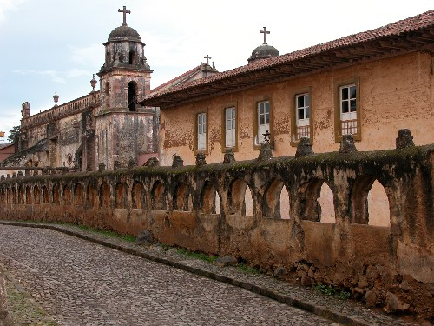
Lodgment at the Hotel Villa Montaña;
Spread over secluded acres in the Santa Maria Hills, Villa Montaña has a spectacular view of Morelia and its baroque Cathedral below- Cottage-Style rooms and suites intermingle amid gardens and multilevel pathways to form and exclusive “mini-village. Superb pieces of art and antiques from Mexico and Europe have been added to the already vast collection that decorates every corner of the property. Villa Montaña is a member of Virtuoso Conde Nast Johansens and Mexico Boutique Hotels
Overnight in the Hotel

DAY 09
MORELIA – PATZCUARO
Breakfast at the Hotel
Departure to visit Patzcuaro is a large town and municipality located in the state of Michoacán. The town was founded sometime in the 1320s. After the Spanish took over, Vasco de Quiroga worked to make Pátzcuaro the capital of the New Spain province of Michoacán, but after his death, the capital would be moved to nearby Valladolid (today Morelia).
Take a little tour in a mini boat in Janitzio is located a top the hill. Janitzio can only be reached by boats which run regularly back and forth from about 7:30 am to 6 pm, accessible from Pátzcuaro's pier. These boats can be hired to take you around other parts of the lake.
Overnight in Patzcuaro at the hotel Porton del Cielo or Gateway to Heaven in English. This because Patzcuaro means "where the entrance to Paradise is", the locals consider the Lake Patzcuaro as the "gateway to heaven." The hotel is set up in a hill were you have the most amazing views to the lake and the entire village.
Overnight

DAY 10
PATZCUARO - MEXICO CITY
Breakfast at the Hotel
After breakfast, we will continue our trip back to Mexico city to spend our last night in Mexico.

DAY 11
MEXICO CITY – OUT
After breakfast, or at appropriate time you will be transfer in a private vehicle and assisted by our guide to the Airport to take flight to return Home.
Late checkout available upon request

The Alico Premium Tours:
The hospitality of a 100% Mexican Team is waiting for your passengers

Alico Dining Program
- All meals included on every program, offering leading & typical restaurants.
- Complimentary bottled water and wet towels every day
- Welcome cocktail with general information at our meeting at the hotel
- Specialized guides during the whole trip
- Alico Personal Concierge available 24/7, based in Mexico City
- Detailed daily briefings by our guide
- Entrance fees of the mentioned visits and activities on the program
- Personalized handcraft as gift
Our prices do not include:
- International or domestic Flights
- Injury, accident, sickness or repatriate insurance
- Changes in programs due to unforeseen reasons
- Personal expenses
- Important changes on petrol prices in Mexico
- Beverages in meals

Notes:
- Museums are closed on Monday in Mexico Country
- Check out times at hotels: 12h00
- Check in at hotels: 15h00
- Rainy Season in Mexico is approximately between May and September each year
- Unfavorable weather conditions or events beyond our control, may lead us, for security reasons, to cancel some trips.
- Gasoline and diesel are cheap in Mexico because of a major grant from the Federal Government, but this grant will disappear, not knowing the date of death or new conditions, we wish to inform you that our prices are likely experience an increase because of this.
- In Mexico Country, Triple rooms do not have 3 beds. Hotels provide always 2 double beds.
- Tubs in bathrooms are never guaranteed unless specifically requested and confirmed.
- Museums are closed on Monday
- Check out times at hotels: 12h00
- Check in at hotels: 15h00
- Maximum 2 children less than 11 years old are permitted on the same room with 2 adults; rooms have only 2 double beds, no extra beds are available.
- If the passengers have a departure flight at 10h00 or before, please consider they won’t have the breakfast of that day because they have to register on the flight 3 hours prior to departure time
- Rainy Season in Mexico is approximately between May and September each year
- In Mexico, the hotels do not count with smoking rooms. Passengers are prohibited from smoking in enclosed areas. Hotels have the right to ask passengers paying a fine of $ 300 USD for those who smoke inside the rooms.
- Gasoline and diesel are cheap in Mexico because of a major grant from the Federal Government, but this grant will disappear, not knowing the date of death or new conditions, we wish to inform you that our prices are likely experience an increase because of this.
- For technical reasons, this circuit as well as elements of the program may be modified or replaced.
- At the airport of origin, the suitcases are documented to their final destination, but without exception, all passengers must clear customs with their luggage on arrival in Mexico City. (No exceptions, please double check the schedules of connecting flights)
- Foreigners that do require a visa for Mexico may visit Mexico if they hold a valid U.S visa or are permanent residents of the United States, Canada, Japan, the United Kingdom and countries that comprise the Schengen area. Please double check the nationality of your passengers. Consider that the Passport and the USA visa have to be valid at least 6 months after passenger’s end of the trip.
- The Tour Operator “---- “must verify if the passengers need a VISA to enter. ALICO TOURS is not responsible in case the passengers don’t have a visa to enter in the countries offered, please double check this.
- The tour operator must send us the dates of birth of all the participants, in order to avoid misunderstandings when an ADULTS ONLY hotel is reserved.
- Alico tours send in every proposal the web page of each hotel suggested. However, is the responsibility of the tour operator to look over the websites of each hotel, in order to select the most suitable accommodation according to the expectations of the client who is requesting the trip. In case of an explicit request from the client, the tour operator must let Alico tours know about any particular request and make changes in time to avoid a disappointed customer at their arrival. The expenses caused by the omission of information from the foreign tour operator will not be Alico Tours responsibility and it will be charge to the foreign tour operator.
- Our prices are subject to important variation in Exchange rate between USD and Mexican peso

