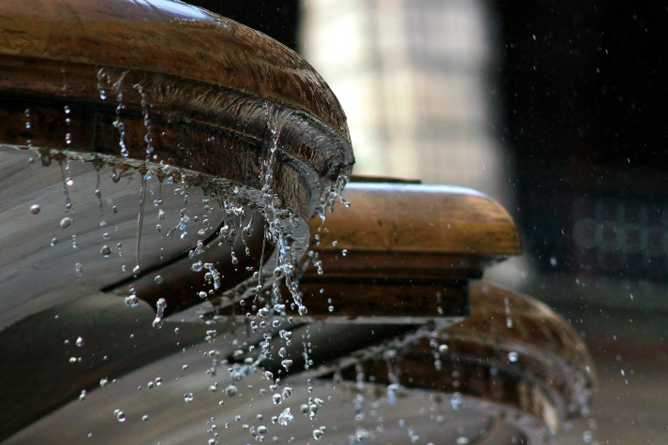***Mexico &Yucatan 2016***

***Deluxe services***

**DAY 01**

**EUROPE – MEXICO**

Arrival to Mexico City, upon arrival at the airport, you will be met and assisted with your transfer to the hotel on the edge of Mexico City ***Hotel Condesa DF;*** *Tucked between historic facades on a tree-lined road in Mexico City’s trendy Condesa neighborhood, the Condesa DF fuses the spirit of its bohemian surroundings with a playfully simple design aesthetic. The Terrace on the fourth floor-bound for leisure-, you can enjoy the smart sushi menu along with a drink from the healthy bar, while contemplating the views of the Castle of Chapultepec and España Park.*

**DAY 2**

**MEXICO – CITY TOUR – MEXICO**

Breakfast at the hotel

This morning you will visit the Anthropology Museum (closed on Mondays) *it is located on Reforma Ave, this spectacular museum besides assembling the most incredible archaeological and ethnographic heritage.*

Continue to visit *National Palace, with Diego Rivera Murals Zocalo**Square and Metropolitan Cathedral embodying centuries of history and refinement, Mexico’s historic city center harbors more than 1,500 buildings that constitute the beating heart of the country.*

Return to the Hotel and Overnight

**DAY 3**

**MEXICO – TEOTIHUACAN – MEXICO**

Breakfast at the hotel

After Breakfast, you set out for a visit to *3 Culture Square and Guadalupe shrine.*

Continue to the most important archaeological site of Mexico: *Teotihuacán (42 km from Mexico City) Teotihuacan, which means the place where men become gods. These are among the most important pre-Hispanic ruins in the Americas due to their masterful urban layout, the monumental architecture and the strong religious and political influence that Teotihuacan held over other cities, here we will visit the Pyramids of the Sun and the Moon.*

Return to Mexico City and lodging

**DAY 4**

**MEXICO – MERIDA**

Breakfast at the hotel

Transfer to the airport to take flight to Merida **(FLIGHT TICKET NOT INCLUDED)**

Arrival to Merida and transfer to the **Hotel Casa Lecanda;** *is a small luxury boutique hotel. Built in a completely restored traditional Yucatecan home, Casa Lecanda offers seven distinct rooms uniquely decorated with custom crafted furniture, original clay tile floors, beautifully restored doors and windows.*

Time to spend the afternoon in Merida and find fine pieces of crafts

Overnight at the hotel

**DAY 5**

**MERIDA - UXMAL/KABAH - MERIDA**

Breakfast at the hotel

Departure to visit Uxmal and Kabah Sites Uxmal: *is a real jewel of the classic Maya style, where the Maya expressed their beliefs in their temples designs the temple of the diviner (built by a short man who was the king, according to a legend) the nuns quadrangle (where you may admire the splendor of Puuc style in its flat walls and decorated friezes) and the governor’s palace. Kabah: City known as the second greatest religious center of the Puuc style. It communicates with Uxmal via a sacbé (Mayan road) that originates in El Arco, main door to the city. The most outstanding building is the Palacio de los Mascarones shows its impressive facade composed of 250 large masks of the God Chaac, carved in stone.*

Return to Merida and overnight at the hotel

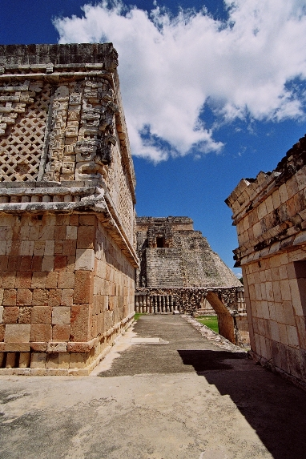

**DAY 06**

**MERIDA - CHICHEN ITZA – RIVIERA MAYA**

Breakfast at the hotel

Departure to Chichen Itza and visit, *In this place, declared a World Heritage Site by UNESCO, you will be transported to pre-Hispanic times to discover the secrets that hold their most important buildings: the Castle or Pyramid of Kukulcan, where every year during the spring equinox think of a natural phenomenon of light and shadows projected on the steps of the Great Pyramid, lowering the image of the "feathered serpent".*

Continue to Riviera Maya, the most peaceful and beautiful beach in Mexico, at your arrival you will be lodge in the Hotel Esencia *villas where guests enjoy genuine privacy and top fine hospitality.*

Overnight

**DAY 7**

**RIVIERA MAYA**

Day at leisure to pamper yourself in Mexican warm waters

Overnight

**DAY 8**

**PLAYA DEL CARMEN- EUROPE**

Breakfast at the Hotel

After breakfast, you will be transfer in a private vehicle and assisted by our guide to the Airport to take flight to return Home.

Late checkout available upon request

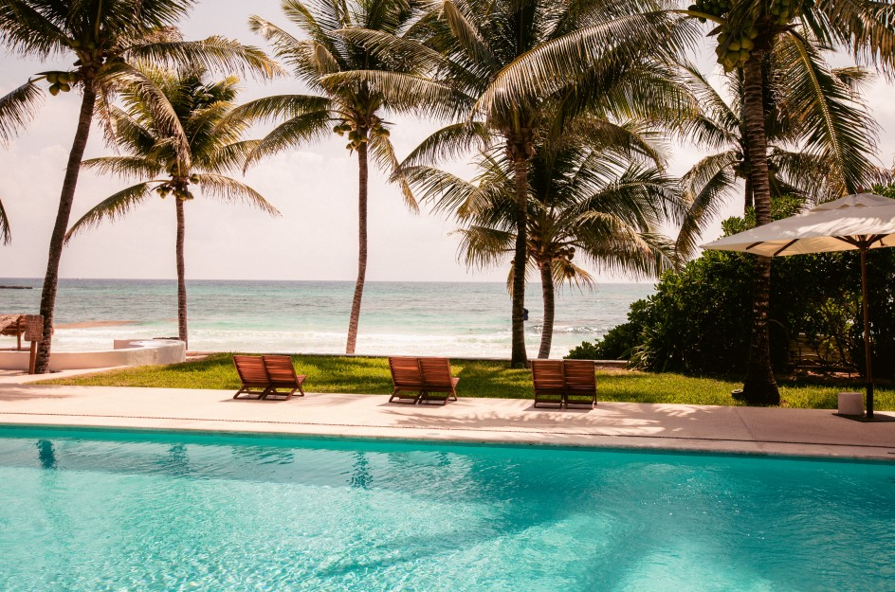

The Alico Premium Tours:

The hospitality of a 100% Mexican Team is waiting for your passengers

Alico Dining Program

* All meals included on every program, offering leading & typical restaurants.
* Complimentary bottled water and wet towels every day
* Welcome cocktail with general information at our meeting at the hotel
* Specialized guides during the whole trip
* Alico Personal Concierge available 24/7, based in Mexico City
* Detailed daily briefings by our guide
* Entrance fees of the mentioned visits and activities on the program
* Personalized handcraft as gift

Our prices do not include:

* International Flights
* Domestic flights
* Injury, accident, sickness or repatriate insurance
* Changes in programs due to unforeseen reasons
* Personal expenses
* Important changes on petrol prices in Mexico
* Beverages in meals

Notes:

* *Museums are closed on Monday in Mexico Country*
* *Check out times at hotels: 12h00*
* *Check in at hotels: 15h00*
* *Rainy Season in Mexico is approximately between May and September each year*
* *Unfavorable weather conditions or events beyond our control, may lead us, for security reasons, to cancel some trips.*
* *Gasoline and diesel are cheap in Mexico because of a major grant from the Federal Government, but this grant will disappear, not knowing the date of death or new conditions, we wish to inform you that our prices are likely experience an increase because of this.*
* *In Mexico Country, Triple rooms do not have 3 beds. Hotels provide always 2 double beds.*
* *Tubs in bathrooms are never guaranteed unless specifically requested and confirmed.*
* *Museums are closed on Monday*
* *Check out times at hotels: 12h00*
* *Check in at hotels: 15h00*
* *Maximum 2 children less than 11 years old are permitted on the same room with 2 adults; rooms have only 2 double beds, no extra beds are available.*
* *If the passengers have a departure flight at 10h00 or before, please consider they won’t have the breakfast of that day because they have to register on the flight 3 hours prior to departure time*
* *Rainy Season in Mexico is approximately between May and September each year*
* *In Mexico, the hotels do not count with smoking rooms. Passengers are prohibited from smoking in enclosed areas. Hotels have the right to ask passengers paying a fine of $ 300 USD for those who smoke inside the rooms.*
* *Gasoline and diesel are cheap in Mexico because of a major grant from the Federal Government, but this grant will disappear, not knowing the date of death or new conditions, we wish to inform you that our prices are likely experience an increase because of this.*
* *For technical reasons, this circuit as well as elements of the program may be modified or replaced.*
* *At the airport of origin, the suitcases are documented to their final destination, but without exception, all passengers must clear customs with their luggage on arrival in Mexico City. (No exceptions, please double check the schedules of connecting flights)*
* *Foreigners that do require a visa for Mexico may visit Mexico if they hold a valid U.S visa or are permanent residents of the United States, Canada, Japan, the United Kingdom and countries that comprise the Schengen area. Please double check the nationality of your passengers. Consider that the Passport and the USA visa have to be valid at least 6 months after passenger’s end of the trip.*
* *The Tour Operator “---- “must verify if the passengers need a VISA to enter. ALICO TOURS is not responsible in case the passengers don’t have a visa to enter in the countries offered, please double check this.*
* *The tour operator must send us the dates of birth of all the participants, in order to avoid misunderstandings when an ADULTS ONLY hotel is reserved.*

*Alico tours send in every proposal the web page of each hotel suggested. However, is the responsibility of the tour operator to look over the websites of each hotel, in order to select the most suitable accommodation according to the expectations of the client who is requesting the trip. In case of an explicit request from the client, the tour operator must let Alico tours know about any particular request and make changes in time to avoid a disappointed customer at their arrival. The expenses caused by the omission of information from the foreign tour operator will not be Alico*