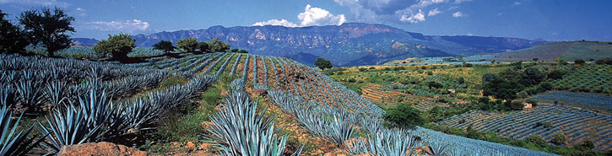
Charming Tequila
Deluxe services

DAY 01
ARRIVAL AT GUADALAJARA
At your arrival at the airport in Guadalajara City, you will be met and assisted for our English speaking guide and transfer in a private vehicle to the Hotel Villa Ganz (Boutique): Housed in a historic 1930s mansion, Villa Ganz has been acclaimed as the First Luxury Boutique Hotel in Guadalajara.
PM Our tour guide will pick you up this evening for a drive through the main streets and avenues of the city After dinner your tour guide will take you back to the hotel. Overnight

DAY 02
GUADALAJARA
Breakfast at the hotel
Panoramic tour of the Minerva Fountain, the Arches, the University of Guadalajara and the gothic Expiatory Church, we will arrive to the historical downtown where we will visit the magnificent colonial buildings like: the Cathedral (visit to the crypts), the Government Palace, the Degollado Theatre, the Tapatian Plaza and the Cabañas Institute
Continue to Tlaquepaque, the famous artisan village where, old colonial mansions are now shops, perfect showcases for the large variety of Mexican arts & crafts.
Return to the Hotel and lodging

DAY 03
GUADALAJARA - TEQUILA
Breakfast at the hotel Transfer to Train Station in Guadalajara to take train to Tequila Town by Jose Cuervo Express (operates: Saturday, departure at: 11h00)
After 14 years the train returns to Tequila. Jose Cuervo ® Express is responsible for dusting the railway in Tequila. Visit the blue agave fields and see the jimadores at work, tending, harvesting and trimming the giant piñas. Take a tour of La Rojeña take part in a professional tasting in the private cellar where the Premium Reserva de la Familia is aged, and sample this superb tequila straight from barrel. Then transfer to the Hotel Solar de las Animas. Overnight

DAY 04
TEQUILA – PUERTO VALLARTA – PUNTA MITA
Breakfast. Departure to Punta Mita, a popular but low-key vacation spot. Hollywood celebrities such as Demi Moore, Orlando Bloom and Vince Vaughn have vacationed.
Our hotel will be the Four Seasons; this expansive hotel has three swimming pools, two private beaches, 10 tennis courts and 2 golf courses. Overnight

DAY 05
PUNTA MITA
Day at leisure to pamper yourself in the beautiful property of the Four Seasons Hotel
Overnight

We suggest:

Marieta Islands an amazing ecological adventure
There is no turning back, you have boarded a ship, bringing along your snorkel and fins, and are about to begin one of the most beautiful and surprising ecotourism adventures in Mexico. Enjoy the ride, because during the course of 45 minutes you will be able to see a landscape where
There will be nothing but the tranquility of the ocean, and if you are lucky, you will be able to see some sunbathing sea turtles, dolphins and even whales.
The ship has stopped, it is time to dive. Surrounded by spectacular marine wildlife, the Marieta Islands are the perfect place to go snorkeling, and you will be able to see from sea turtles, stingrays and dolphins, to octopus and humpbacked whales. Get ready! You have discovered Playa Escondida (Hidden Beach), a short stretch of beach half covered by a wall of rocks in the heart of the Marieta Islands.
Enjoy the tranquility offered by this beach. Let yourself go with the sound of the wind which blends with the crashing waves, while you watch hundreds of birds that fly over the beach.

DAY 06
PUERTO VALLARTA - MEXICO CITY - EUROPE
Breakfast at the Hotel
After breakfast, you will be transfer in a private vehicle and assisted by our guide to the Airport to take flight to return Home.
Late checkout available upon request

PRICES ON REQUEST

